**DAILY ONLINE ACTIVITIES SUMMARY**

|  |  |  |  |  |  |  |  |  |
| --- | --- | --- | --- | --- | --- | --- | --- | --- |
| **Date:** | **08-07-2020** | | | | | **Name:** | **Anix Jugal D’Cunha** | |
| **Sem & Sec** | **8 sem , A sec** | | | | | **USN:** | **4AL16CS013** | |
| **Online Test Summary** | | | | | | | | |
| **Subject** | | **Not Conducted** | | | | | | |
| **Max. Marks** | | **--** | | **Score** | | | **--** | |
| **Certification Course Summary** | | | | | | | | |
| **Course** | HTML5 - Basics to Advanced | | | | | | | |
| **Certificate Provider** | | | **Udemy** | | **Duration** | | | 3.5 hours |
| **Coding Challenges** | | | | | | | | |
| **Problem Statement:** Java program to rotate the elements in the given array | | | | | | | | |
| **Status: Competed** | | | | | | | | |
| **Uploaded the report in Github** | | | | | **yes** | | | |
| **If yes Repository name** | | | | | **alvas-education-foundation/dcunhaanixjugal** | | | |
| **Uploaded the report in slack** | | | | | **yes** | | | |

Online Test Details: (Attach the snapshot and briefly write the report for the same)

**Not Conducted**

Certification Course Details: (Attach the snapshot and briefly write the report for the same)

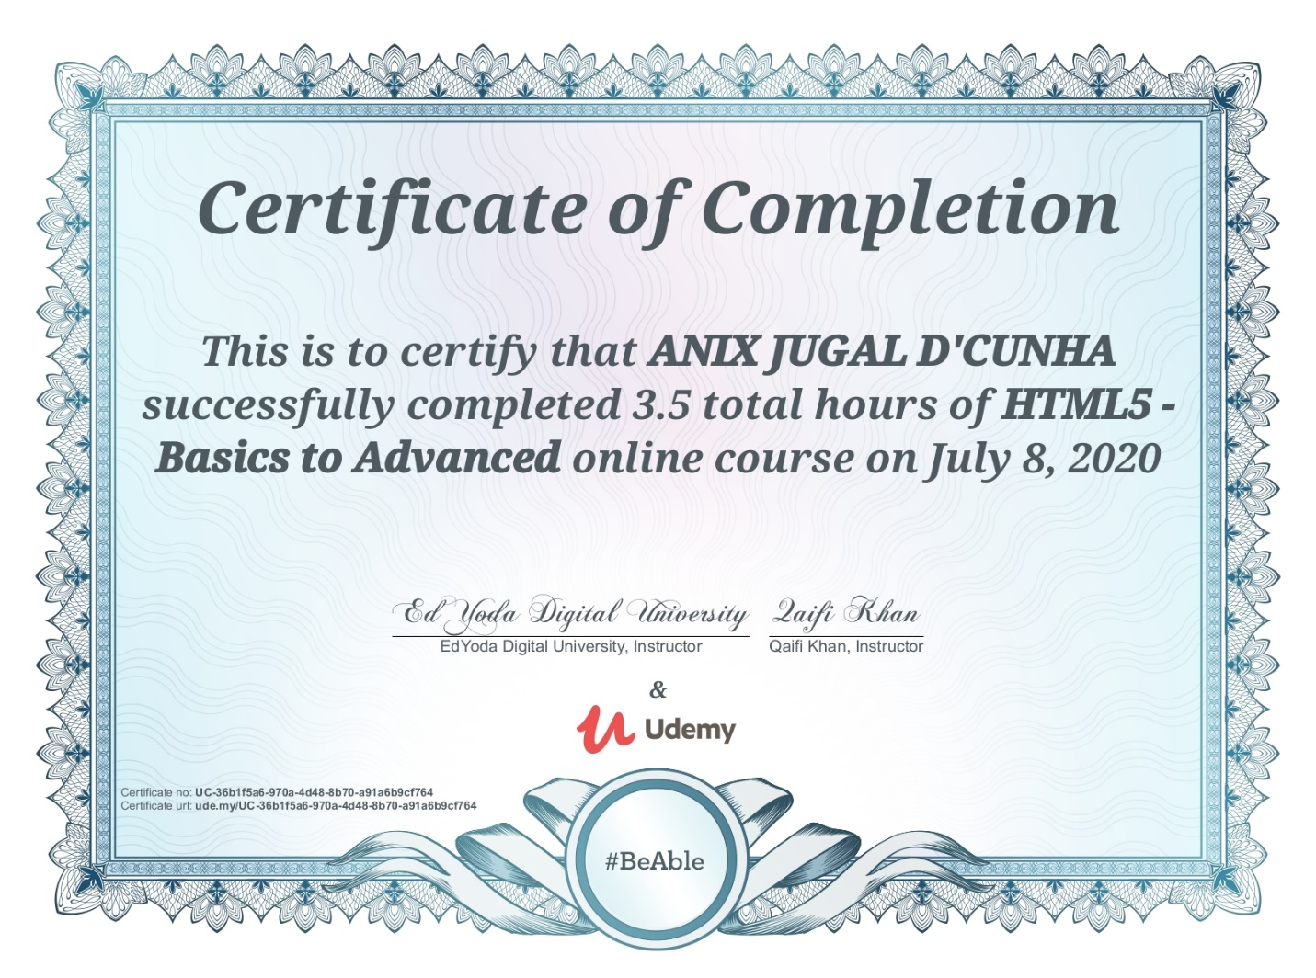

Coding Challenges Details: (Attach the snapshot and briefly write the report for the same)

## Program-> ****Java program to rotate the elements in the given array****

|  |
| --- |
|  |

**class RotateRight {**

**public static void main(String[] args) {**

**int [] arr = new int [] {1, 2, 3, 4, 5};**

**int n = 3;**

**System.out.println("Original array: ");**

**for (int i = 0; i < arr.length; i++) {**

**System.out.print(arr[i] + " ");**

**}**

**for(int i = 0; i < n; i++){**

**int j, last;**

**last = arr[arr.length-1];**

**for(j = arr.length-1; j > 0; j--){**

**arr[j] = arr[j-1];**

**}**

**arr[0] = last;**

**}**

**System.out.println();**

**System.out.println("Array after right rotation: ");**

**for(int i = 0; i< arr.length; i++){**

**System.out.print(arr[i] + " ");**

**}**

**}**

**}**

**Output:**

**Original Array:**

**1 2 3 4 5**

**Array after right rotation:**

**3 4 5 1 2**